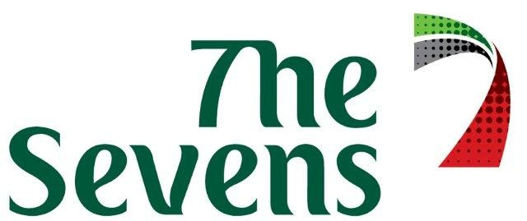

TERMS AND CONDITIONS FOR CASUAL HIRE BOOKINGS
CRICKET, SPORTS PITCHES, COURTS & FACILITY HIRE

A casual hire* is an individual or one-off booking that does not form part of a regular series of bookings.
* The minimum hire duration for a casual sports pitch hire is 1.5 hours
** The minimum hire duration for a casual cricket pitch hire is 4 hours
*** The minimum hire duration for a casual court hire is 1 hour

All grass oval bookings will receive FOC 2 cases of water (24 bottles per case) per 4 hour booking.
Bookings confirmed for the grass ovals will also include 1 concrete practice net which will be available for use 30 minutes prior to the scheduled booking time through until the completion of the booking time – subject to availability.

1.0 Payment Terms

Full payment must be received (and cleared) prior to the booking commencing.

All charges relating to all bookings must be received as per the payment term above, unless alternative payment terms have been confirmed in advance in writing by The Sevens management.

In addition to normal UAE financial rules regarding dishonoured cheques, an administrative fee of AED 250 will apply for every bounced, dishonoured or returned unprocessed cheque.

2.0 Non Payment

Failure to comply with the payment term will result in bookings being cancelled. If bookings are cancelled due to any non-payment, Emirates shall not refund any advance payments received for the cancelled bookings and the Hirer shall remain liable for any unpaid charges applicable to those cancelled bookings.
No new bookings will be accepted until all outstanding accounts have been paid.

3.0 Cancellation and Refund Policy

Any cancellation within 7 days of the applicable hire date or a booking no show will result in 100% of all charges continuing to be liable for payment to Emirates.

Transfer of a booking date due to UAE religious or public holidays may be permitted.

Emirates reserve the right to alter or cancel bookings or to implement block-out dates. If a booking is cancelled by Emirates, any advance payments relating to the cancelled booking will be refunded.

4.0 Disclaimer

The hirer will be liable and responsible for any personal injury, accident or death, or any loss or damage to The Sevens facility or personal property or vehicles caused by any organisers, participants, spectators or invitees attending any of the hirer’s activities in connection with a booking. The hirer will be responsible for obtaining any insurance in relation to its activities or its guest’s use of the stadium as it deems appropriate.

Unless specifically agreed in writing, Emirates is not responsible for providing any security, medical assistance or facilities (including any first aid or ambulance services) or any other requirements in connection with any event conducted by the hirer in connection with a booking.

The Hirer will be responsible for complying with all official and/or legal requirements in relation to any event conducted by the Hirer in connection with a booking.

This agreement is exclusive to the Hirer who may not sublease any terms and conditions to a third party.

Initial & Date ………………………………..

5.0 Conditions

As a courtesy to other users, the Hirer must ensure they vacate and leave the pitches and/or facilities clean and tidy during and at the completion of their allocated time. Failure to do so will result in any additional clean up time being charged.

Only those persons authorised in writing by the hirer can uplift goods on behalf of the hirer.

It is a Stadium rule that no food or beverage (including liquor) that has not been purchased from The Sevens can be consumed on the premises or elsewhere on the site including vehicles and buildings. It is also a government licence condition that no liquor can be taken off site. These rulings are non-negotiable and any organisation or persons found disregarding this condition will risk immediate cancellation of the game in progress and any future approval for their or their organisations use of the facility. Also in addition to this ruling you may be charged a AED 5,000 fine and until this is paid in full no further bookings will be accepted from the organisation.

Dogs or other animals are strictly prohibited from The Sevens Stadium or grounds at any time.

For sports pitch bookings high Lux Level volume lighting (ie. for international and/or televised events) is available upon request. Additional charges apply.

All facility users are required to act responsibly and respect the stadium and other users at all times whilst at The Sevens. Any damage to the stadium and/or its equipment, if caused by the hirer or their guests, shall be charged to the hirer including any replacement of items with new equipment if repair is not acceptable to Emirates.

Emirates reserves the right to refuse admission at any time to any person or group due to unacceptable behaviour or refusing to follow rules and conditions operating at The Sevens.

By signing this contract the booking co-ordinator accepts, on behalf of the Hirer,
“The Sevens” Terms & Conditions of use above.

Name (BLOCK CAPS)

Club/Organisation

Club Title/Role

Contact Tel No.

Contact Email Add.

Address ___________________________________________________

___________________________________________________

Signature ___________________________________________________

Date ___________________________________________________

BookingTerms&Conditions 31.7.2015

